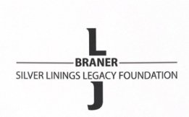
The LJ Braner Silver Linings Legacy Foundation
LJ Braner Academic Scholarship
2024 SCHOLARSHIP APPLICATION
(Application Deadline: Monday, May 15, 2024, by 6PM)
This scholarship is awarded to an individual who has challenged themselves in high-level classes (AP/Honors) and learned what it takes to overcome obstacles to persevere. The individual recipient will be able to document how their personal growth and focus on the future endeavors of attending a two-year or four-year college are essential to success.
Answer each question and take as much space as you need. If you need to add additional pages that is fine. All questions must be answered.

- LIST SIGNIFICANT HIGH SCHOOL ACTIVITIES: Projects, activities, organizations, leadership roles, awards, honors, etc., since you entered high school.

- What are some of the toughest challenges you faced in high school? How did you overcome these challenges?

- Tell us about your experience with YBA and how it has impacted you?

- Please provide additional information about yourself that would assist the Scholarship Committee with its decision.

- Explain how/why you have selected your chosen college. Include your future schooling/training for preparation for your career.

- Please enclose a copy of your unofficial transcript.

